7COM1079-0901-2025 - Team Research and Development Project

Final report title: COVID-19 Weekly Deaths: Comparing High-Income and Low-Income Countries

Group ID: A188

Dataset number: Ds030

Prepared by: Purna Satish Dasari (23004891)
Harish Attaluri (24083900)
Sowmya Kondam (23040940)
Pallapolu Bhanu Prakash Reddy (23035556)
Chandra Sekhar Chintapalli (23032622)
Date: 12/12/2025

University of Hertfordshire
Hatfield, 2025

Table of Contents
1. Introduction 3
1.1 Problem Statement and Research Motivation 3
1.2 The Data 3
1.3 The Research Question 3
1.4 The Hypotheses 4
2. Background Research 5
2.1 Previous Research Findings 5
2.2 Why RQ is of Interest 5
3. Visualization 6
3.1 Visualizations Created 6
Figure 1: Mean Weekly Deaths by Income Group 6
Figure 2: Distribution of Weekly Deaths 6
Figure 3: Weekly Deaths in High-Income Countries 7
Figure 4: Weekly Deaths in Low-Income Countries 7
3.2 What the Data Looked Like in the Plots 8
3.3 Useful Information for Data Understanding (Key Numbers) 8
4. Analysis 9
4.1 Statistical Tests Applied 9
4.2 Hypothesis Decision 9
5. Evaluation 10
5.1 What Went Well 10
5.2 Points for Improvement 10
5.3 Time Management 10
5.4 Overall Assessment 11
5.5 Comment on GitHub log output 11
6. Conclusions 12
6.1 Results Explained 12
6.2 Interpretation of the Results 12
6.3 Reasons and Implications for Future Work, Limitations 12
7. References 13
8. Appendix 14

1. Introduction

1.1 Problem Statement and Research Motivation
During the COVID-19 pandemic, an odd pattern was observed. Some countries reported way more deaths than others. A natural question arose: did wealthy countries have more deaths, or did they just report them better? This distinction matters significantly because it affects how global health data is interpreted. The World Health Organization (2021) estimated that actual COVID-19 mortality globally was substantially higher than reported figures, particularly in low-income regions where deaths may be underestimated by factors of five to ten. High-income countries possess good hospitals and testing capacity. Deaths can be counted accurately. Low-income countries struggle with limited resources. They cannot test everyone. Therefore, when reported numbers are compared, different things may be compared. What was recorded may not match what happened.

1.2 The Data
Data came from Our World in Data COVID-19 dataset. This dataset contains COVID-19 statistics for countries worldwide. The period covered was January 2020 to March 2023. From this dataset, two specific groups were extracted based on World Bank income classifications. High-income countries have GNI per capita above $12,696. Low-income countries have GNI below $1,046. After filtering, there were 1,138 weekly observations for high-income countries and 1,106 for low-income countries. Missing values were removed during cleaning.

1.3 The Research Question
Is there a difference in the mean weekly COVID-19 deaths between high-income and low-income countries?
This research question directly addresses whether officially reported COVID-19 mortality differed significantly between economically distinct country groups during the pandemic period.

1.4 The Hypotheses
H0 (Null Hypothesis): There is no significant difference in mean weekly COVID-19 deaths between high-income and low-income countries.
H1 (Alternative Hypothesis): There is a significant difference in mean weekly COVID-19 deaths between high-income and low-income countries.
To test these hypotheses, Welch's independent samples t-test was selected as the primary statistical test. This test is appropriate because it compares means between two groups without assuming equal variances a critical consideration given the substantially different variability observed in preliminary data examination. A Wilcoxon rank-sum test was conducted as a non-parametric alternative, given that both distributions violated normality assumptions. Results were considered statistically significant at the conventional threshold of p < 0.05.

2. Background Research

2.1 Previous Research Findings
Bambra et al. (2020) demonstrated that poorer populations and countries experienced worse COVID outcomes. Higher infection and death rates were observed. Overcrowded housing, limited healthcare access, and higher rates of underlying health conditions contributed to these disparities. Patel et al. (2020) examined vulnerable populations in low-income countries. It was found that limited testing and weak death recording systems resulted in many COVID deaths going uncounted. This limitation poses a major challenge when comparing countries. The WHO (2021) estimated that actual COVID deaths globally exceeded reported figures significantly. In low-income regions, true deaths were estimated to be 5 to 10 times higher than official numbers. This discrepancy is substantial. Riffe et al. (2021) conducted analysis of actual versus expected deaths. High-income countries maintained careful COVID death recording. Low-income countries faced considerably worse recording due to insufficient testing capacity and incomplete death registration systems.

2.2 Why RQ is of Interest
This question addresses a real gap in understanding pandemic data. Looking at income groups shows differences in surveillance capacity. Big differences in reported deaths have two possible causes. Either disease burden was genuinely different. Or detection and reporting were different. Both matter for policy. If rich countries report more deaths despite similar exposure, something needs explaining. This could involve testing, demographics, or transparency. Understanding these differences helps global health planning. It also highlights a critical need. Low-income countries need better death registration systems. Without accurate counting, health improvements cannot be properly targeted or measured.

3. Visualization

3.1 Visualizations Created
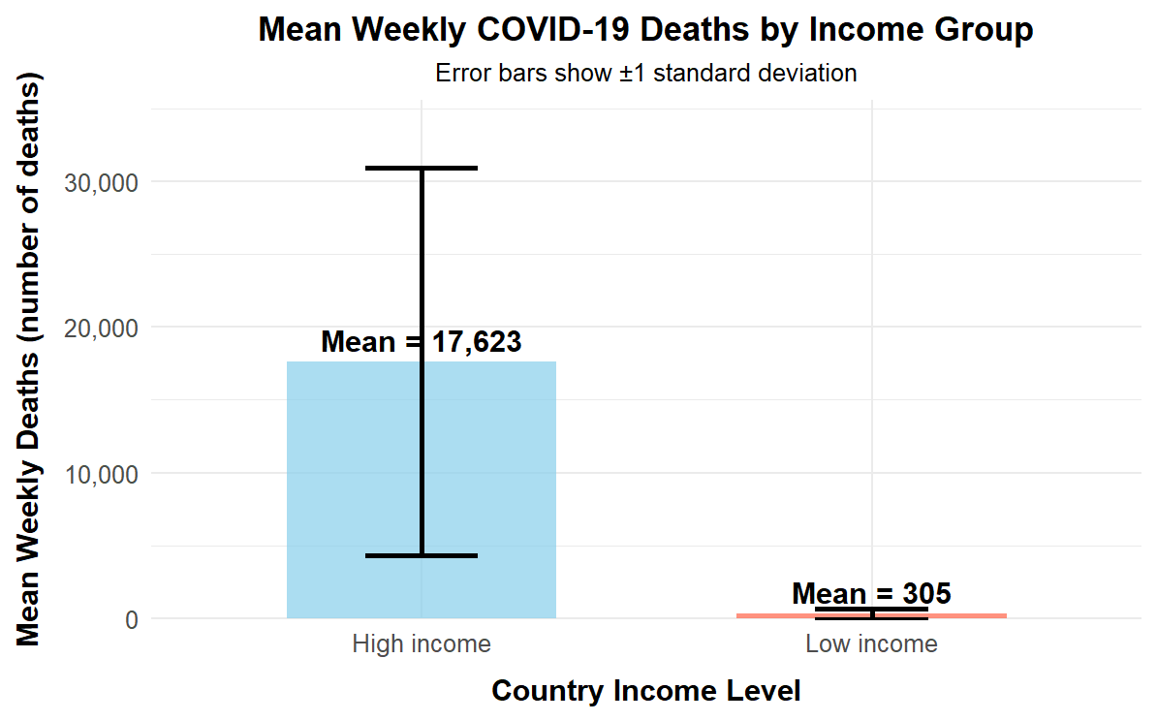

Figure 1: Mean Weekly Deaths by Income Group
FIGURE 1: Mean Weekly Deaths by Income Group: This shows average deaths with error bars showing variation.
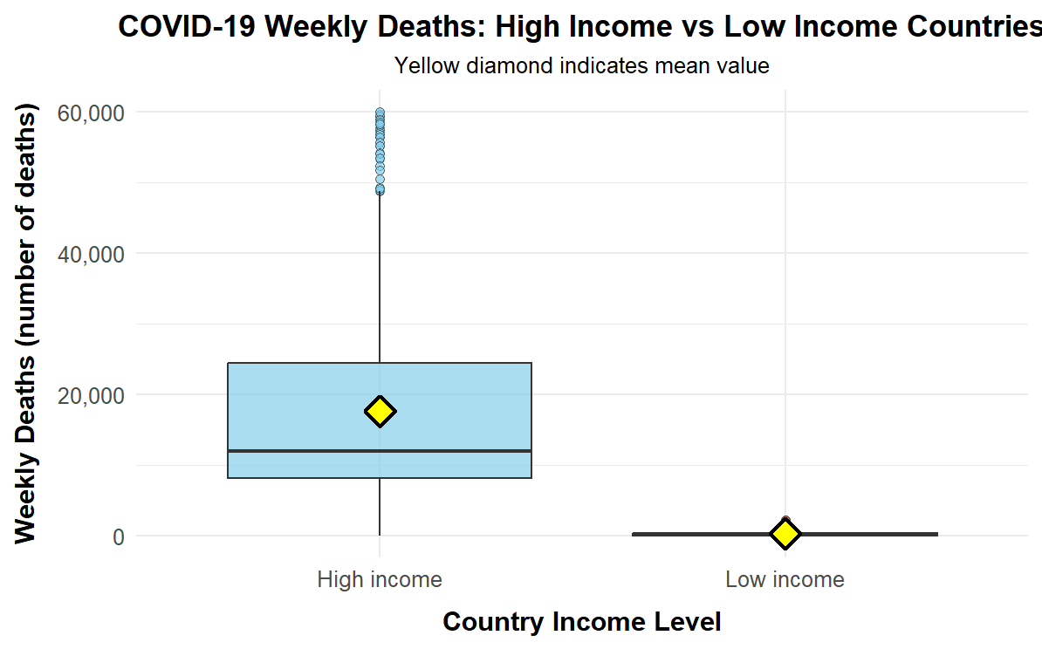

Figure 2: Distribution of Weekly Deaths
FIGURE 2: Distribution of Weekly Deaths: This shows the middle values, spread, and outliers for each group.

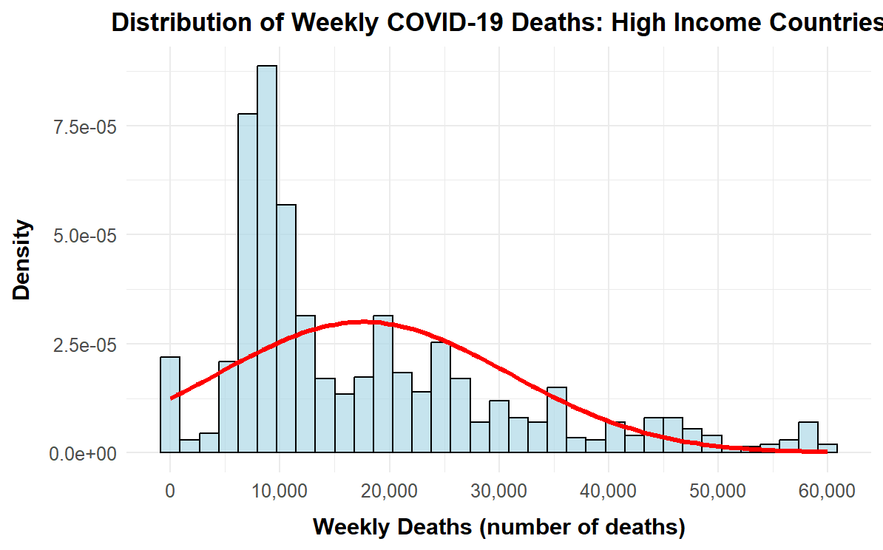

Figure 3: Weekly Deaths in High-Income Countries

FIGURE 3: High-Income Countries: This shows how many weeks had different death counts.

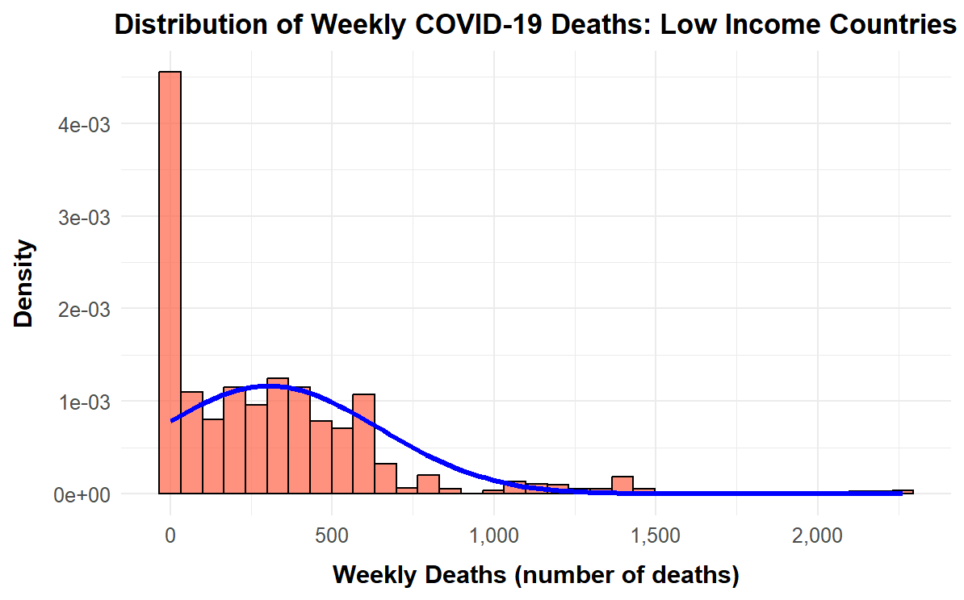

Figure 4: Weekly Deaths in Low-Income Countries

FIGURE 4: Low-Income Countries: This shows the same for low-income countries

3.2 What the Data Looked Like in the Plots
The plots show important patterns. High-income countries had huge variation in weekly deaths. Values ranged from zero to 60,026 per week. Multiple peaks appeared for different pandemic waves. Low-income countries showed much lower numbers. Maximum was only 2,263 per week. Both distributions were right-skewed. Some extreme weeks pulled the data away from normal distribution. This is typical for death count data.

3.3 Useful Information for Data Understanding (Key Numbers)

Statistic | High Income | Low Income
Number of weeks | 1,138 | 1,106
Mean deaths | 17,623 | 305
Median deaths | 11,983 | 228
Standard deviation | 13,294 | 342
Minimum deaths | 0 | 0
Maximum deaths | 60,026 | 2,263

The median is lower than the mean for both groups. This shows extreme weeks pulled averages higher. High-income maximum was 27 times larger than low-income maximum.

4. Analysis

4.1 Statistical Tests Applied
Welch's t-test was the main test. It compares means between independent groups. It works when variances are unequal. The data had very different standard deviations (13,294 vs 342). Wilcoxon rank-sum test was also applied. This is a non-parametric test. It works with non-normal data. Both distributions failed normality tests. Cohen's d measured effect size. All tests used two-tailed hypotheses. Significance level was p < 0.05.

4.2 Hypothesis Decision
Decision: The null hypothesis is REJECTED.
Welch's t-test gave these results: t = 43.93, p < 0.0001. The 95% confidence interval was [16,545 to 18,092]. The huge t-value shows a massive difference. The tiny p-value shows this is not chance. High-income countries reported 17,623 mean weekly deaths. Low-income countries reported 305. The difference is 17,318 deaths per week. Wilcoxon test confirmed this (W = 1,218,407, p < 0.0001). Cohen's d was 1.83. This is a very large effect. But this does not mean rich countries had worse COVID. It likely means they detected and recorded deaths better.

5. Evaluation

5.1 What Went Well
The analysis ran smoothly from start to finish. Data from Our World in Data was well-organized. Only minimal cleaning was needed. Missing value removal kept over 99% of data. When R code encountered macOS compatibility issues, the team successfully tested on Windows, highlighting the importance of cross-platform verification. The ggplot2, dplyr, and effsize packages all ran smoothly. Multiple plots showed the data from different angles. Histograms showed the data was not normal. This justified using both parametric and non-parametric tests. Team communication was good. Tasks were clearly divided. GitHub kept everything organized.

5.2 Points for Improvement
The main problem was comparing absolute numbers instead of rates. High-income countries have 1.2 billion people. Low-income countries have 700 million. Deaths per 100,000 population would be fairer. Time analysis was also missing. The pandemic hit regions at different times. Looking at waves separately would help. Country-level analysis would reveal differences within income groups. Including testing rates, vaccination data, and healthcare spending would explain the gap better. These are all missed opportunities.

5.3 Time Management
The project followed a sequential structure, beginning with data acquisition and cleaning before progressing to exploratory analysis and statistical testing. Upon completion of the analytical phase, attention shifted to generating visualizations and drafting the final report. The efficiency of the data preparation stage allowed for a more in-depth focus on graphical representation. Although the documentation phase required substantial effort, the proactive organization ensured a smooth project conclusion.

5.4 Overall Assessment
The project achieved its goals. A significant difference was found and measured. The findings were carefully interpreted. Limitations were acknowledged. This shows both the power and limits of data analysis. Statistics can prove a difference exists. But understanding why requires context and critical thinking. The project successfully demonstrated both aspects.

5.5 Comment on GitHub log output

The complete GitHub log is provided in Appendix B, documenting all team contributions. Three significant commits demonstrate project progression:
Commit 1: "Add COVID-19 analysis script" (12 Dec, Purna & Chandra) - This implemented all statistical tests including Welch's t-test, Wilcoxon test, and Cohen's d, establishing the analytical foundation.
Commit 2: "Update README.md" (12 Dec, Harish) - This documented findings and created project summary with clear explanation of results and interpretations.
Commit 3: " Modified Research question and best one." (04 Dec, Chandra) - This modified the Research Question.

6. Conclusions

6.1 Results Explained
High-income countries reported much higher mean weekly COVID deaths than low-income countries. The difference was 17,318 deaths per week. High-income averaged 17,623. Low-income averaged 305. This was statistically significant at p < 0.0001. The chance of this happening randomly is less than 0.01%. Welch's t-test and Wilcoxon test both agreed. Cohen's d was 1.83. This is a very large effect. The groups barely overlapped.

6.2 Interpretation of the Results
Higher reported deaths in rich countries probably reflect better detection rather than worse disease. Several things explain this. Rich countries tested millions of people. They could find cases and link deaths to COVID. Poor countries could not test enough. Many deaths were missed. Rich countries have complete death registration systems. Poor countries often do not. Many deaths go unrecorded. Population age matters too. Rich countries are older (median age 40). Poor countries are younger (median age 20). Older people die more from COVID. The numbers show detection capacity, not necessarily true disease burden.

6.3 Reasons and Implications for Future Work, Limitations
Limitations: Absolute counts were used instead of population rates. Age differences were not adjusted for. Time patterns were not examined properly. Different pandemic waves were mixed. Excess mortality was not included.
Future Research: Future research should calculate deaths per 100,000 population. Use age-standardised rates. Do time-series analysis. Look at pandemic waves separately. Include excess mortality estimates. Add variables like healthcare spending, testing rates, and vaccination coverage. These improvements would give better understanding of where disease burden was highest. Better death registration in poor countries is critically needed.

7. References

Bambra, C., Lynch, J. and Smith, K.E. (2020) ‘The pandemiology of inequalities’, The Lancet, 397(10), pp. 1341–1342.​
Patel, J.A., Nielsen, F.B.H., Badiani, A.A., Assi, S., Unadkat, V.A., Patel, B. and Ravindrane, R. (2020) ‘Poverty, inequality and COVID-19: the forgotten vulnerable’, Public Health, 183, pp. 110–111. doi: 10.1016/j.puhe.2020.05.006.​
Riffe, T., Acosta, E., Bas, A., Kontis, V., Ndiaye, S.M. and Shirreff, G. (2021) ‘Assessing the impact of COVID-19 on global excess mortality estimates’, medRxiv (preprint).​
World Health Organization (2022) ‘14.9 million excess deaths were associated with the COVID-19 pandemic in 2020 and 2021’. Available at: https://www.who.int/news/item/05-05-2022-14.9-million-excess-deaths-were-associated-with-the-covid-19-pandemic-in-2020-and-2021 (Accessed: 12 December 2025).

8. Appendix
Appendix A: R Code
library(ggplot2)
library(dplyr)
library(effsize)
library(scales)

covid_data <- read.csv("full_data.csv")

analysis_data <- covid_data %>%
filter(location %in% c("High income", "Low income")) %>%
filter(!is.na(weekly_deaths))

analysis_data$income_group <- factor(analysis_data$location)

descriptive_stats <- analysis_data %>%
group_by(income_group) %>%
summarise(
n = n(),
mean = mean(weekly_deaths),
median = median(weekly_deaths),
sd = sd(weekly_deaths),
min = min(weekly_deaths),
max = max(weekly_deaths),
IQR = IQR(weekly_deaths)
)

print(descriptive_stats)

high_income_mean <- descriptive_stats$mean[descriptive_stats$income_group == "High income"]
low_income_mean <- descriptive_stats$mean[descriptive_stats$income_group == "Low income"]
high_income_sd <- descriptive_stats$sd[descriptive_stats$income_group == "High income"]
low_income_sd <- descriptive_stats$sd[descriptive_stats$income_group == "Low income"]
high_income_n <- descriptive_stats$n[descriptive_stats$income_group == "High income"]
low_income_n <- descriptive_stats$n[descriptive_stats$income_group == "Low income"]

high_income_deaths <- analysis_data %>%
filter(income_group == "High income") %>%
pull(weekly_deaths)

low_income_deaths <- analysis_data %>%
filter(income_group == "Low income") %>%
pull(weekly_deaths)

shapiro_high <- shapiro.test(high_income_deaths)
shapiro_low <- shapiro.test(low_income_deaths)

print(shapiro_high)
print(shapiro_low)

t_test_result <- t.test(weekly_deaths ~ income_group, data = analysis_data, var.equal = FALSE)
print(t_test_result)

wilcox_result <- wilcox.test(weekly_deaths ~ income_group, data = analysis_data)
print(wilcox_result)

cohens_d_result <- cohen.d(weekly_deaths ~ income_group, data = analysis_data)
print(cohens_d_result)

t_statistic <- t_test_result$statistic
t_df <- t_test_result$parameter
t_pvalue <- t_test_result$p.value
effect_size <- cohens_d_result$estimate

histogram_high <- ggplot(analysis_data %>% filter(income_group == "High income"), aes(x = weekly_deaths)) +
geom_histogram(aes(y = after_stat(density)), bins = 35, fill = "lightblue", color = "black", alpha = 0.7) +
stat_function(fun = dnorm, args = list(mean = mean(high_income_deaths), sd = sd(high_income_deaths)), color = "red", linewidth = 1.3) +
scale_x_continuous(labels = comma, breaks = seq(0, 60000, 10000)) +
scale_y_continuous(labels = scientific) +
labs(
title = "Distribution of Weekly COVID-19 Deaths: High Income Countries",
x = "Weekly Deaths (number of deaths)",
y = "Density"
) +
theme_minimal(base_size = 14) +
theme(
plot.title = element_text(size = 16, face = "bold", hjust = 0.5),
plot.subtitle = element_text(size = 12, hjust = 0.5),
axis.title.x = element_text(size = 14, face = "bold", margin = margin(t = 10)),
axis.title.y = element_text(size = 14, face = "bold", margin = margin(r = 10)),
axis.text = element_text(size = 12)
)
print(histogram_high)
ggsave("histogram_high_income.png", histogram_high, width = 10, height = 6, dpi = 300)

histogram_low <- ggplot(analysis_data %>% filter(income_group == "Low income"), aes(x = weekly_deaths)) +
geom_histogram(aes(y = after_stat(density)), bins = 35, fill = "tomato", color = "black", alpha = 0.7) +
stat_function(fun = dnorm, args = list(mean = mean(low_income_deaths), sd = sd(low_income_deaths)), color = "blue", linewidth = 1.3) +
scale_x_continuous(labels = comma, breaks = seq(0, 2500, 500)) +
scale_y_continuous(labels = scientific) +
labs(
title = "Distribution of Weekly COVID-19 Deaths: Low Income Countries",
x = "Weekly Deaths (number of deaths)",
y = "Density"
) +
theme_minimal(base_size = 14) +
theme(
plot.title = element_text(size = 16, face = "bold", hjust = 0.5),
plot.subtitle = element_text(size = 12, hjust = 0.5),
axis.title.x = element_text(size = 14, face = "bold", margin = margin(t = 10)),
axis.title.y = element_text(size = 14, face = "bold", margin = margin(r = 10)),
axis.text = element_text(size = 12)
)

print(histogram_low)
ggsave("histogram_low_income.png", histogram_low, width = 10, height = 6, dpi = 300)
boxplot_comparison <- ggplot(analysis_data, aes(x = income_group, y = weekly_deaths, fill = income_group)) +
geom_boxplot(alpha = 0.7, outlier.shape = 21, outlier.size = 2) +
stat_summary(fun = mean, geom = "point", shape = 23, size = 5, fill = "yellow", color = "black", stroke = 1.5) +
scale_fill_manual(values = c("High income" = "skyblue", "Low income" = "tomato")) +
scale_y_continuous(labels = comma) +
labs(
title = "COVID-19 Weekly Deaths: High Income vs Low Income Countries",
subtitle = "Yellow diamond indicates mean value",
x = "Country Income Level",
y = "Weekly Deaths (number of deaths)"
) +
theme_minimal(base_size = 14) +
theme(
plot.title = element_text(size = 16, face = "bold", hjust = 0.5),
plot.subtitle = element_text(size = 12, hjust = 0.5),
axis.title.x = element_text(size = 14, face = "bold", margin = margin(t = 10)),
axis.title.y = element_text(size = 14, face = "bold", margin = margin(r = 10)),
axis.text = element_text(size = 12),
legend.position = "none"
)
print(boxplot_comparison)
ggsave("boxplot_comparison.png", boxplot_comparison, width = 10, height = 7, dpi = 300)

bar_chart <- ggplot(descriptive_stats, aes(x = income_group, y = mean, fill = income_group)) +
geom_bar(stat = "identity", alpha = 0.7, width = 0.6) +
geom_errorbar(aes(ymin = mean - sd, ymax = mean + sd), width = 0.25, linewidth = 1.1) +
geom_text(aes(label = sprintf("Mean = %s", comma(round(mean)))), vjust = -0.5, size = 5, fontface = "bold") +
scale_fill_manual(values = c("High income" = "skyblue", "Low income" = "tomato")) +
scale_y_continuous(labels = comma, expand = expansion(mult = c(0, 0.15))) +
labs(
title = "Mean Weekly COVID-19 Deaths by Income Group",
subtitle = "Error bars show ±1 standard deviation",
x = "Country Income Level",
y = "Mean Weekly Deaths (number of deaths)"
) +
theme_minimal(base_size = 14) +
theme(
plot.title = element_text(size = 16, face = "bold", hjust = 0.5),
plot.subtitle = element_text(size = 12, hjust = 0.5),
axis.title.x = element_text(size = 14, face = "bold", margin = margin(t = 10)),
axis.title.y = element_text(size = 14, face = "bold", margin = margin(r = 10)),
axis.text = element_text(size = 12),
legend.position = "none"
)

print(bar_chart)
ggsave("bar_chart_means.png", bar_chart, width = 10, height = 7, dpi = 300)

R Code Description
Install packages
library(ggplot2)
library(dplyr)
library(effsize)
Load data
covid_data <- read.csv("full_data.csv")
Filter and prepare
analysis_data <- covid_data %>%
filter(location %in% c("High income", "Low income")) %>%
filter(!is.na(weekly_deaths))
Descriptive statistics
analysis_data %>%
group_by(location) %>%
summarise(n = n(), mean = mean(weekly_deaths),
median = median(weekly_deaths), sd = sd(weekly_deaths))
Normality test
shapiro.test(high_income_deaths)
shapiro.test(low_income_deaths)
t-test
t.test(weekly_deaths ~ location, data = analysis_data, var.equal = FALSE)
Wilcoxon test
wilcox.test(weekly_deaths ~ location, data = analysis_data)
Effect size
cohen.d(weekly_deaths ~ location, data = analysis_data)

Appendix B: Complete GitHub Log

Date | Author | Commit | Message
12 Dec 2025, 18:25 IST | ha24agc (Harish) | 0f00bd9 | Update README.md
12 Dec 2025, 18:15 IST | sowmyakondam (Sowmya) | 7c4bd17 | Uploaded relevant papers
12 Dec 2025, 18:13 IST | ha24agc (Harish) | 5902ffe | Create Papers Folder
12 Dec 2025, 18:12 IST | sowmyakondam (Sowmya) | 738cd3c | Delete papers
12 Dec 2025, 18:12 IST | sowmyakondam (Sowmya) | 34b99b8 | Create Papers folder
12 Dec 2025, 15:49 IST | Sat99496 (Purna) | 64f485d | Add new updated RQ Template
12 Dec 2025, 15:48 IST | Sat99496 (Purna) | 209cd47 | Delete reseach_question_presentation_for_git.pptx
12 Dec 2025, 14:29 IST | Cc23chint (Chandra) | aed4bb2 | Update Plots
12 Dec 2025, 11:59 IST | Cc23chint (Chandra) | 998f730 | Update Covid Analysis R Script
12 Dec 2025, 11:58 IST | Cc23chint (Chandra) | 6edd76b | Add COVID-19 analysis R script for Mac
12 Dec 2025, 11:57 IST | Cc23chint (Chandra) | ee704b4 | Update R Code
12 Dec 2025, 11:48 IST | Sat99496 (Purna) | 3109ad8 | Add COVID-19 analysis script
04 Dec 2025, 05:48 IST | Cc23chint (Chandra) | 3efe85c | Modified Research question and best one
04 Dec 2025, 05:48 IST | Sat99496 (Purna) | 26a73e7 | Delete reseach_question_presentation_for_git.pptx
04 Dec 2025, 05:47 IST | Sat99496 (Purna) | 60ee3ae | Research Question Presentation
29 Nov 2025, 05:45 IST | Sat99496 (Purna) | d8ebb59 | Add full_data.csv containing COVID-19 patient data
29 Nov 2025, 05:39 IST | Sat99496 (Purna) | 21fa590 | Initial commit

